AI TRAINING – DAY 3 ASSIGNMENT
Python Operators & Strings: Manipulate → Extract → Clean → Format
Practical + MCQ + Debugging + String Utility Project

1. Learning Goals
- Understand arithmetic, comparison, logical, assignment and membership operators.
- Understand strings, indexing, slicing and common string methods.
- Use f-strings to create readable dynamic output.
- Identify common operator and string errors.
- Combine all topics to build a practical text utility.
- Explain your solution in your own words.

2. Assignment Rules
- Type the programs yourself. Do not copy complete solutions.
- Before running code, predict the output.
- Test strings with spaces, uppercase/lowercase, empty input and unexpected input.
- You may use AI to explain a concept or error after attempting it yourself.
- For every practical problem write Input → Processing → Output.
- Keep at least one error you faced and explain how you fixed it.

3. Part A – Operators Exploration
Create operators.py and experiment with each group. Write at least 2 examples for every group.
Operator group | Operators / your observation
Arithmetic | + - * / // % **  Observation: The Arithmetic operator are used for addition, subtraction, multiplication, division, modulo division and calculating the power
Comparison | == != > < >= <=  Observation: Comparison operator are useful for to check the two values are equal or one value is greater or smaller than another.
Logical | and or not  Observation: Needs both conditions to be True and needs at least one condition to be True.
Assignment | = += -= *= /=  Observation: Assignment operator make it easy to update the value.
Membership | in / not in  Observation: in means some thing is present not in means something is absent.

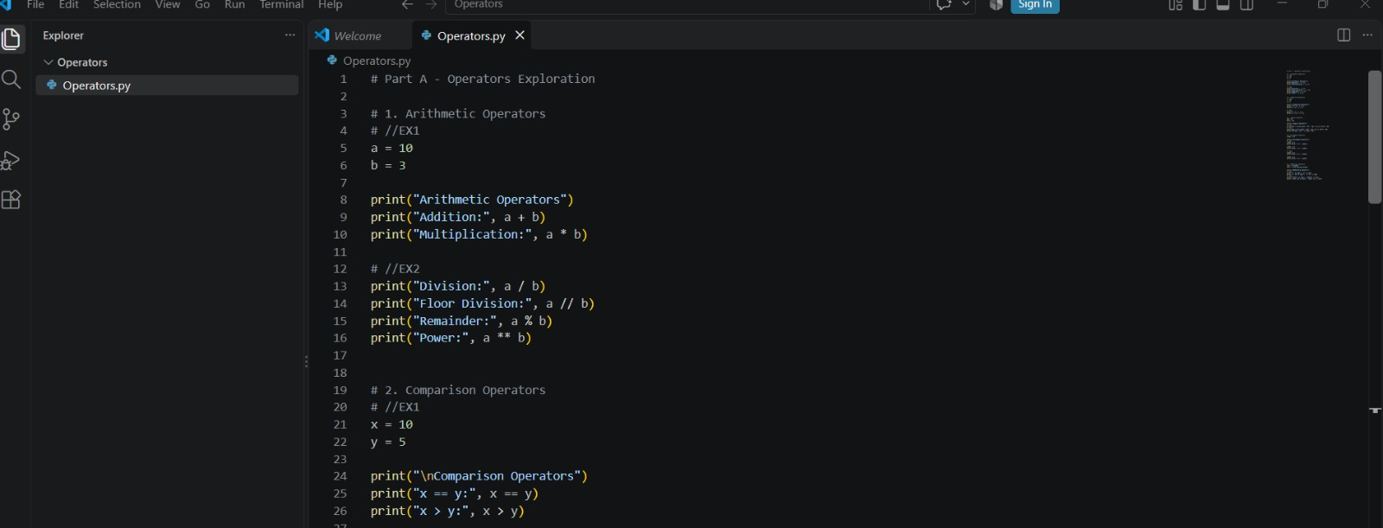
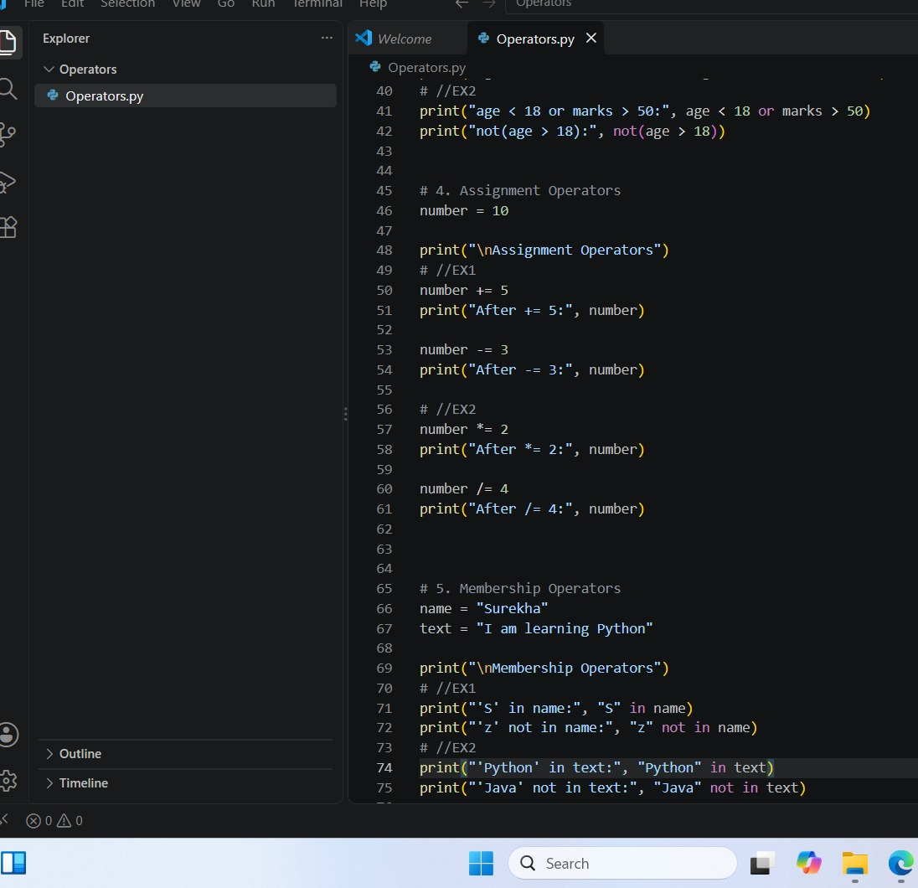

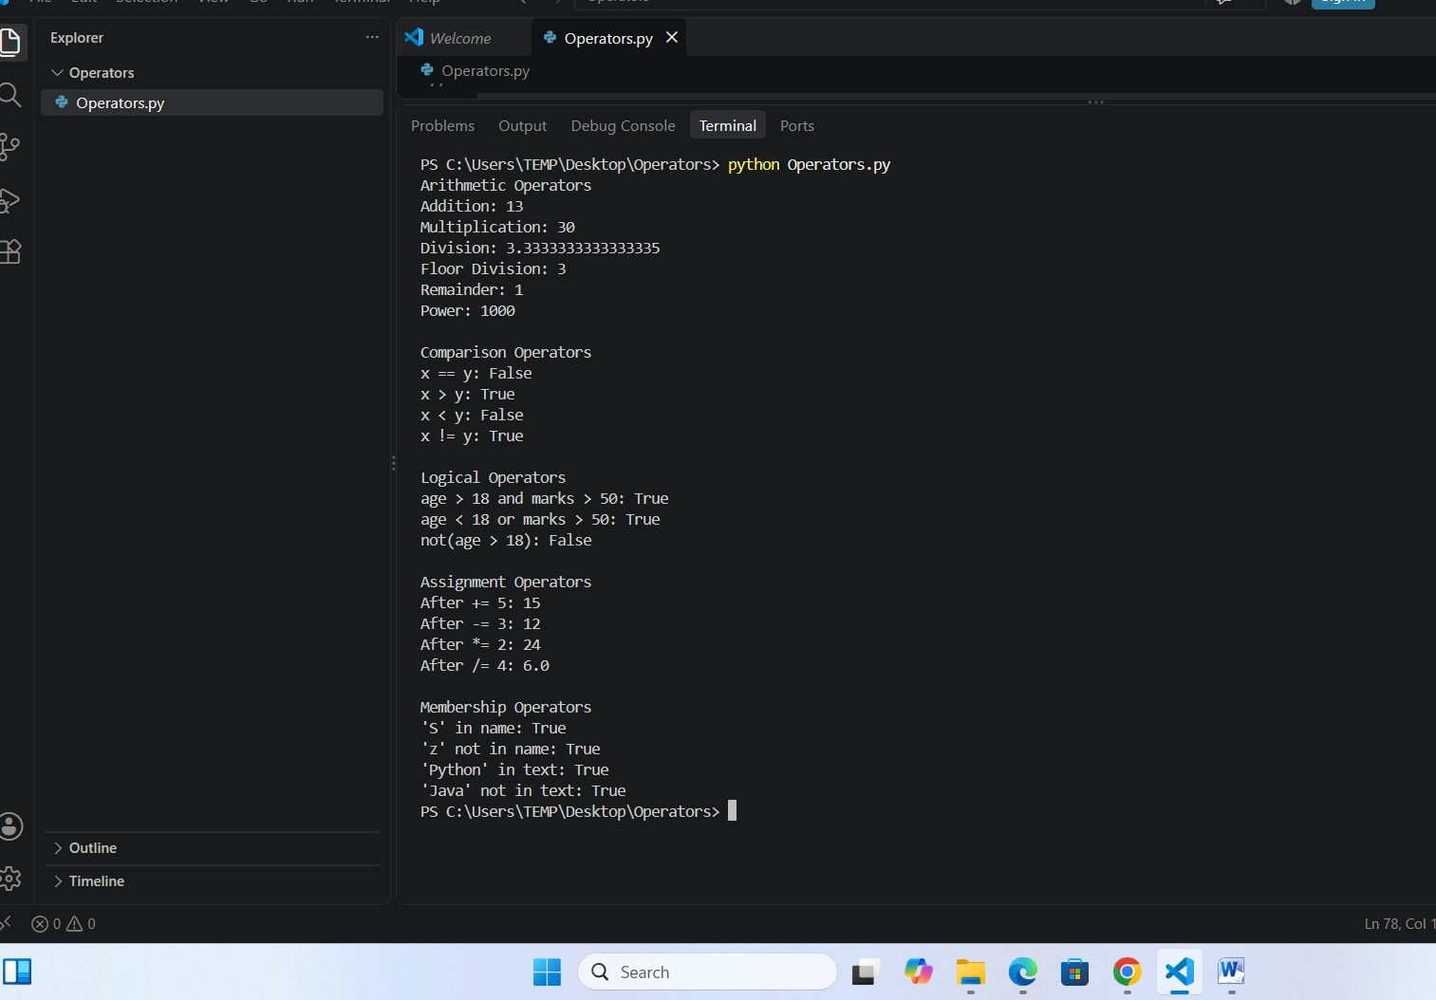

4. Part B – Operator Thinking
- What is the difference between / and //?
Ans: / it usually returns the decimal point.
// it returns only whole numbers.
- When would % be useful in a real application?
Ans: % gives the remainder after division.
for example, when we check a number is even or odd.
- What does ** do?
Ans: ** is used to calculate the power.
- What is the difference between = and ==?
Ans: = is to assign the value.
== is to compare the values.
- What is the difference between != and not?
Ans: != checks the whether two values are different.
Not reverse a boolean result.
- What is the result of 10 > 5 and 3 < 2? Explain.
Ans: 10>5 is True.
3<2 is False.
- What is the result of 10 > 5 or 3 < 2? Explain.
Ans: 10>5 is True.
3<2 is False
- What does not True produce?
Ans: False.
- What does 'Python' in 'I am learning Python' return?
Ans: True.
- When would not in be useful?
Ans: not in useful when we want to check some thing is not present.

5. Part C – String Basics Lab
Use your own name or another sentence and run these experiments.
- Create a string and print it.
Ans: name=”likki”
print(name)
out put: likki
- Print its length using len().
Ans: name=”likki”
print(len(name))
out put: 5
- Print the first character using [0].
Ans: name=”python”
print(name(0))
output: p
- Print the last character using [-1].
Ans: name=”python”
print(name[-1])
output: n
- Print the first 3 characters using slicing.
Ans: name=”python”
print(name[:3])
output: pyt

- Print the last 3 characters using slicing.
Ans: name=”python:
print(name[-3:])
output: hon
- Print every second character.
Ans: name=”python”
print(name[::2])
output: pto
- Reverse the string using slicing.
Ans: name=”python”
print(name[::-1])
output: nohtyp
- Try an invalid index. What error occurs?
Ans: name=”python”
print(name[10])
output: invalid index
- Try changing one character directly. What happens and why?
Ans: name=”python”
name[0]=”j”
output: Type Error
why means Strings are immutable. does not change character directly inside an esisiting string

6. Part D – String Methods Lab
Experiment with these methods and explain what each one does.
Method | Your example | What does it do?
lower() | print(“Hello”.lower)  output: hello | Converts text to lowercase
upper() | print(“hello”.upper())  output: Hello | Converts text to uppercase
title() | print(“hello world”.title())  output: Hello World | Makes first letter of each word uppercase
strip() | print(“hello”.strip())  output: hello | Removes spaces from beginning and end
replace() | print(“i like java”.replace(“java”, “python”))  output: I like python | Replaces one text with another
split() | print(“apple, banana”. Split(“ , ”)  output: ‘apple’, ’banana’ | Splits string into a list
join() | Print(“-”.join([“A”, “B”, “C”])  output: A-B-C | Joins strings together
startswith() | print(“python”.starts with(“py”))  output: True | Checks starting text
endswith() | print(“python”.ends With(“on”))  output: True | Checks ending text
find() | print(“python”.find(“t”))  output: 2 | Finds the position of text
count() | print(“banana”.count(“a”))  output: 3 | Counts how many times text occurs

7. Part E – Indexing & Slicing Challenge
Use: text = "Artificial Intelligence"
- Print the first character.
Ans: print(text[0])
output: A
- Print the last character.
Ans: print(text[-1])
output: e
- Print the first 10 characters.
Ans: print(text[10])
output: Artificial
- Extract the word Intelligence.
Ans: print(text[11])
output: Intelligence
- Reverse the complete string.
Ans: print(text[::-1])
output: ecnegilletni laicifitrA
- Print every second character.
Ans: print(text[::2])
output: AtiaItlgne

- Print characters from index 3 to 12.
Ans: print(text[3:13])
output: ificial In
- Find the index of the first 'i'.
Ans: print(text. find(“i”))
output: 2
- Count the number of 'i' characters.
Ans: print(text. count(“i”))
output: 3
- Predict what text[100] will do, then run it.
Ans: It produces Index Error

8. Part F – f-Strings
- Create name, age and city variables and display them in one sentence using an f-string.
Ans: name=”likhitha”
age=21
city=”kanigiri”
print(f” my name is {name}, I am {age} years old and I live in {city}.”)
- Create a product, price and quantity and display a formatted bill.
Ans: product=”phone”
price=15000
quantity=1
total=price*quantity
print(f” product: {product}”)
print(f” price: {price}”)
print(f” quantity: {quantity}”)
print(f” total: {total}”)
- Display student name, total marks and average.
Ans: name=”likhitha”
marks=450
average=90
print(f” name: {name}”)
print(f” marks: {marks}”)
print(f” average:{average}”)
- Use an f-string to display a calculation result.
Ans: a=10
b=20
result=a+b
print(f” the sum of {a} and{b} is {result}.”)
- Research decimal formatting and display a price with exactly 2 decimal places.
Ans: price=125.5
print(f” print: {print:.2f}”)

9. Part G – MCQs: Basic
1. Which operator means multiplication?
- A. x
- B. *
- C. %
- D. //
2. What does % return?
- A. Division
- B. Quotient
- C. Remainder
- D. Power
3. What is the first string index?
- A. 0
- B. 1
- C. -1
- D. first
4. What is len('Python')?
- A. 5
- B. 6
- C. 7
- D. Error
5. Which gets the last character?
- A. text[0]
- B. text[-1]
- C. text[last]
- D. text[1]
6. Which converts text to lowercase?
- A. lower()
- B. small()
- C. down()
- D. lowercase
7. Which removes leading/trailing spaces?
- A. trim()
- B. clean()
- C. strip()
- D. remove()
8. Which checks membership?
- A. inside
- B. in
- C. has
- D. contains
9. Which is an f-string?
- A. f"Hello {name}"
- B. "f Hello"
- C. format f(name)
- D. string(name)
10. Which compares equality?
- A. =
- B. ==
- C. ===
- D. equals

10. Part H – MCQs: Medium
1. What is 17 // 5?
- A. 3
- B. 3.4
- C. 2
- D. 4
2. What is 17 % 5?
- A. 3
- B. 2
- C. 3.4
- D. 0
3. What does 'Python'[1:4] return?
- A. Pyt
- B. yth
- C. ytho
- D. tho
4. What does 'Python'[-3:] return?
- A. tho
- B. hon
- C. yth
- D. Python
5. What does ' hello '.strip() return?
- A. ' hello'
- B. 'hello '
- C. 'hello'
- D. Error
6. What does 'hello'.upper() return?
- A. hello
- B. HELLO
- C. Hello
- D. Error
7. What does 'a,b,c'.split(',') return?
- A. abc
- B. ['a','b','c']
- C. ('a','b','c')
- D. Error
8. Which checks if AI occurs in text?
- A. text.contains('AI')
- B. 'AI' in text
- C. text.has('AI')
- D. contains(text,'AI')
9. What happens with text[50] when text has 10 characters?
- A. None
- B. ''
- C. Index Error
- D. False
10. Why use f-strings?
- A. Insert values/expressions into strings cleanly
- B. Make strings immutable
- C. Convert values to int
- D. Remove spaces

11. Part I – MCQs: Thinking
1. Which is true about strings?
- A. They can always be changed character-by-character
- B. They are immutable
- C. They only contain letters
- D. They cannot be sliced
2. Best way to clean ' PHANI Gorantla ' for display?
- A. strip().title()
- B. title().strip()
- C. Both A and B
- D. clean()
3. What does text[::-1] do?
- A. Deletes text
- B. Reverses text
- C. Sorts text
- D. Gets first character
4. Best simple test for '@' in an email?
- A. '@' in email
- B. email == '@'
- C. email.contains('@')
- D. email.has('@')
5. replace() generally:
- A. Returns a transformed string
- B. Always changes the original string in place
- C. Converts to list
- D. Deletes the variable
6. x='5', y=2. Which gives numeric 10?
- A. x*2
- B. int(x)*2
- C. str(x)*2
- D. x+2
7. Which formats 12.5 as 12.50?
- A. f'{price:.2f}'
- B. f'{price:2}'
- C. f'{price.float}'
- D. f'{price.decimal(2)}'
8. What should usually happen before validating text entered with spaces?
- A. strip()
- B. reverse()
- C. split() always
- D. replace with None
9. A common cause of Index error is:
- A. Invalid index
- B. Using an f-string
- C. lower()
- D. +
10. Why keep raw input and cleaned input conceptually separate?
- A. It makes transformations easier to test
- B. Python requires it
- C. Strings cannot be stored
- D. It prevents every error

12. Part J – 5 Practice Problems
Problem | Task | Topics
Practice 1 – Username Cleaner | Ask for a username, remove surrounding spaces, convert to lowercase and display the cleaned value. | strip + lower + f-string
Practice 2 – Name Formatter | Ask first and last names in random case and display a properly formatted full name. | strip + title + f-string
Practice 3 – Word Analyzer | Ask for a sentence. Display length, first character, last character, spaces count and vowel count. Do not use loops. | len + indexing + count
Practice 4 – Email Inspector | Ask for an email. Check '@', check whether it ends with '.com' or '.in', and show the position of '@'. | in + endswith + find
Practice 5 – Product Code Extractor | For code IND-MOB-2026-001, extract country, category, year and serial using slicing. | indexing + slicing + f-string
For each: Input → Expected Output → Code → 2 test cases → 1 edge case → explanation.

Practice 1 – Username Cleaner
Task: Ask for a username, remove surrounding spaces, convert to lowercase and display the cleaned value.
Topics: strip() + lower() + f-string
Input:
A username with some spaces and capital letters.
Expected Output:
The username should have no extra spaces and should be in lowercase.
Code:
user Name = input("Enter username: ")
cleaned = userName.strip().lower()
print(f"Cleaned username: {cleaned}")
Test Case 1:
Input: likhitha
Output: Cleaned username: likhitha
Test Case 2:
Input: sravya
Output: Cleaned username: sravya
Edge Case:
Input: likhitha
Output: Cleaned username: likhitha
Explanation:
strip() removes spaces from the beginning and end. lower() converts capital letters to small letters.

Practice 2 – Name Formatter
Task: Ask first and last names in random case and display a properly formatted full name.
Topics: strip() + title() + f-string
Input:
First name and last name in any case.
Expected Output:
Both names should start with a capital letter.
Code:
first_name = input(“Enter first name:”)
last_name = input(“Enter last name:”)
print(f” You full name: {first_name.strip().title()} {last_name.strip().title()}”)
Test Case 1:
Input: lIKhitha
Output: Full name: likhitha
Test Case 2:
Input: RAHUL, KUMAR
Output: Full name: Rahul Kumar
Edge Case:
Input: likhitha
Output: Full name: likhitha
Explanation:
strip() removes extra spaces and title() makes the first letter of each word capital.

Practice 3 – Word Analyzer
Task: Ask for a sentence. Display length, first character, last character, spaces count and vowel count. Do not use loops.
Topics: len() + indexing + count()
Input:
A sentence.
Expected Output:
Length, first character, last character, number of spaces and number of vowels.
Code:
text = input("Enter a sentence: ")
vowel_count = ( text.count("a") + text.count("e") +
text.count("i") + text.count("o") +
text.count("u") +
text.count("A") + text.count("E") +
text.count("I") + text.count("O") +
text.count("U")
)
print(f"Length: {len(text)}")
print(f"First character: {text[0]}")
print(f"Last character: {text[-1]}")
print(f"Spaces: {text.count(' ')}")
print(f"Vowels: {vowel_count}")
Test Case 1:
Input: likhitha
Output:
Length: 8
First character: l
Last character: a
Spaces: 0
Vowels: 2
Test Case 2:
Input: I love Python
Output:
- Length: 13
- First character: I
- Last character: n
- Spaces: 2
- Vowels: 4
Explanation:
len() finds the total number of characters. [0] gives the first character and [-1] gives the last character. count() is used to count spaces and vowels.

Practice 4 – Email Inspector
Task: Ask for an email. Check @, check whether it ends with .com or .in, and show the position of @.
Topics: in + ends with() + find()
Input:
An email address.
Expected Output:
Whether @ is present, whether it ends with .com or .in, and the position of @.
Code:
email = input("Enter email: ")
contains = "@" in email
valid_end = email.endswith(".com") or email.endswith(".in")
at_position = email.find("@")
print(f"Contains @: {contains}")
print(f"Ends with .com or .in: {valid_end}")
print(f"Position of @: {at_position}")
Test Case 1:
Input: rakhi@gmail.com
Output:
Contains @: True
Ends with .com or .in: True
position of@:5

Test Case 2:
Input: rahul@yahoo.in
Output:
Contains @: True
Ends with .com or .in: True
Position of @: 5
Edge Case:
Input: rakhigmail.com
Output:
Contains @: False
Ends with .com or .in: True
Position of @: -1
Explanation:
in checks whether @ is present. ends with() checks how the email ends. find() gives the position of @. If it is not found, find() gives -1.

Practice 5 – Product Code Extractor
Task: For code IND-MOB-2026-001, extract country, category, year and serial using slicing.
Topics: Indexing + slicing + f-string
Input:
A product code like IND-MOB-2026-001.
Expected Output:
Country: IND
Category: MOB
Year: 2026
Serial: 001
Code:
code = input("Enter product code: ")
country = code[0:3]
category = code[4:7]
year = code[8:12]
serial = code[13:16]
print(f"Country: {country}")
print(f"Category: {category}")
print(f"Year: {year}")
print(f"Serial: {serial}")
Test Case 1:
Input: IND-MOB-2026-001
Output:
Country: IND
Category: MOB
Year: 2026
Serial: 001
Test Case 2:
Input: CAN-CAP-2025-025
Output:
Country: USA
Category: LAP
Year: 2025
Serial: 025
Edge Case:
Input: IND-TAA-2026-999
Output:
Country: IND
Category: TVX
Year: 2026
Serial: 999
Explanation:
Slicing is used to take specific parts from the product code. For example, code[0:3] takes the first 3 characters

13. Part K – Debugging Lab

Bug 1
name = input('Name: ')
print(name[20])
Why can this fail? Fix it.
Corrected code: name=input(“name”)
if len(name)>20: print(name[20])
else:
print(“The name is too short.”)
Explanation: Before using an index, we should check whether that index actually exists.

Bug 2
age = '20'
print(f'Age: {age + 1}')
Fix it.
Corrected code: age=20
print(f’Age: {int(age)+1})
Explanation: int(age) converts the string ‘20’ into the integer 20. then 1 can be added to it.

Bug 3
name = 'phani'
age = 30
print('Hello ' + name + age)
Identify the type problem and fix it.
Corrected code: name=”likki”
age=21
print(“hello {likki}, your age is {age}”)
Explanation: The f string allows us to easily combine text and numbers in one sentence.(name) and (age) insert their values into the string.

Bug 4
email = input('Email: ')
print(email.endswith('.com'))
Test with 3 inputs and explain.
Corrected code: email = input("Email: ")
email = email.strip().lower()
print(email.endswith(".com") or email.endswith(".in"))
Explanation: The bug is related to string validation . The corrected code checks the email after removing and converting it to lower case.

Bug 5
code = 'IND-MOB-2026-001'
print(code[20])
Find the valid index range and fix the requirement.
Corrected code: code=’IND-MOB-2026-001’
print(code[0])
Explanation: Python starts counting string positions from 0 to 16 so code[20] causes Index error.

Bug 6
text = ' hello world '
print(text.upper().strip())
Does it work? Explain the order of operations.
Corrected code: text = ' hello world '
cleaned = text.upper().strip()
print(cleaned)
Explanation: First, upper() changes the letters into lower case. Then, strip() removes the extra spaces from both ends.

14. Part L – Main Project: Text-Cleaning & Profile Formatter
Build a practical Python program that accepts messy profile information and converts it into a clean, readable profile.

Scenario
A company receives profile data in inconsistent formats. Names may contain extra spaces, emails may use mixed cases, and cities may be entered randomly. Your program should clean the data and generate a professional profile summary.

Required Inputs
- Full name
- Email address
- Phone number
- City
- Job role
- Short bio

Must-Have Requirements
- Remove leading/trailing spaces.
- Format the full name using title().
- Convert email to lowercase.
- Format city and job role neatly.
- Calculate bio character count.
- Check whether the email contains '@'.
- Check whether the email ends with a supported domain such as .com or .in.
- Extract first name from the full name.
- Extract last name using string logic.
- Display the profile using f-strings.
- Show a small data-quality section.
- Test with messy uppercase/lowercase and extra spaces.

Expected Output Example
================ PROFILE ================
Name : Phani Gorantla
First Name : Phani
Email : phani@example.com
Phone : 9876543210
City : Hyderabad
Role : Software Developer
Bio Length : 42 characters
------------- DATA QUALITY -------------
Email Valid : Yes
=========================================
Do not hard-code the example. The program must work with any user's input.

15. Project Bonus Challenges
- Clean repeated spaces inside a name.
- Validate phone number length.
- Check that the full name contains at least two words.
- Generate initials from the name.
- Generate a username from the person's name.
- Create a one-line professional bio using an f-string.
- Display a simple data-quality percentage.

Code :
full_name = input("Enter full name: ").strip().title()
email = input("Enter email: ").strip().lower()

phone = input("Enter phone number: ").strip()
city = input("Enter city: ").strip().title()
job_role = input("Enter job role: ").strip().title()
bio = input("Enter short bio: ").strip()
name_parts = full_name.split()
if (len(phone) > 10):
print("Invalid phone number")
else:
print("Phone number is valid")
if (len(name_parts) >= 2):
print("Full name is valid")
else:
print("Please enter first and last name")
username = full_name.lower().replace(" ", "")
print(f"Username: {username}")
professionalBio = (f"{full_name} is a {job_role} from {city}.")
print(professionalBio)
first_name = name_parts[0]
bio_length = len(bio)
has_at = "@" in email
supported_domain = email.endswith(".com") or email.endswith(".in")
if has_at and supported_domain:
email_valid = "Yes"
else:
email_valid = "No"
print("\n============ PROFILE =============")
print(f"Name: {full_name}")
print(f"First Name: {first_name}")
print(f"Last Name: {last_name}")
print(f"Email: {email}")
print(f"Phone: {phone}")
print(f"City: {city}")
print(f"Role: {job_role}”)
print(f"Bio Length : {bio_length} characters")
print("\n------------- DATA QUALITY -------------")
print(f"Email Valid : {email_valid}")
print("=======================")

16. Project Test Cases

16. Project Test Cases
Test | Input condition | Expected behavior | Actual result
1 | Normal clean input | Clean profile | Profile was created correctly.
2 | Extra spaces around fields | Spaces removed | Extra spaces were removed successfully.
3 | Random uppercase/lowercase | Proper formatting | The text was changed into the proper format.
4 | Invalid-looking email | Flag data quality | The invalid email was identified.
5 | Short/missing optional data | Program should handle it sensibly | Program continues without crashing

17. Explain Your Project
- What is the difference between cleaning data and formatting data?
Ans: Cleaning data means removing unwanted or incorrect things from the input.
Formatting data means making the cleaned data look neat.
- Which string methods did you use and why?
Ans: strip() is used for to remove the extra spaces.
Lower() is used for to covert lower case to uppercase.
Upper() is used for to convert uppercase to lowercase.
Split() is used for separate the spaces.
Find() is used for to find the position.
Count() is used for to count the characters.
- Where did you use indexing?
Ans: I used indexing to access individual characters.
- Where did you use slicing?
Ans: Slicing is used when we want a part of a string.
- Why are f-strings useful here?
Ans: f-strings are useful because they allow us to easily put variables inside text.
- What error did you face?
Ans:One common error I faced was:
Index Error
- How did you test edge cases?
Ans: I tested the program with
Empty input
Extra spaces
Uppercase text
Lowercase text

- If this processed 1 lakh profiles, what would you improve first?
Ans: I would first improve data validation and performance.

18. Final Self-Check
Skill | Yes | Need Practice | Notes
Use arithmetic/comparison/logical operators | yes | ☐ | I can use operators like +, -, <, >,==.
Explain = vs == | yes | ☐ | It used for to assign the value and == is to compare the values.
Manipulate strings | yes | ☐ | I can join, change and work with text strings.
Use positive and negative indexing | yes | ☐ | I can access characters from the beginning or one from the end of a string.
Use slicing | yes | ☐ | I can take a particular part of a string using slicing
Use string methods | yes | ☐ | I can use methods like upper(), lower() and replace().
Use in/not in | yes | ☐ | I can check whether a character a word is present in string.
Use f-strings | yes | ☐ | I can put variables values directly inside a string using f” ”
Debug Index Error/type problems | yes | ☐ | I can identify simple indexing and data type errors and correct them.
Build the final text utility | yes | ☐ | I can combine these concepts to create a simple text processing program.

19. Submission Checklist
- Operator experiments
- Operator questions
- String exploration
- String-method table
- Indexing/slicing challenge
- f-string exercises
- 30 MCQ answers
- 5 practice programs
- Debugging Lab
- Text-Cleaning & Profile Formatter
- Project test cases
- Project explanation and self-check

